**YOUTH PROTECTION**

**& PROGRAM SUPPORT**

**AT THE UNIVERSITY OF UTAH**

SAFETY OF MINORS POLICY



**YOUTH PROTECTION AND PROGRAM SUPPORT**

[youthprotection.utah.edu](https://youthprotection.utah.edu/) (801) 581-4444

[youthprotection@utah.edu](mailto:youthprotection@utah.edu)

REGISTRATION PORTAL GUIDE

EDITING A SESSION

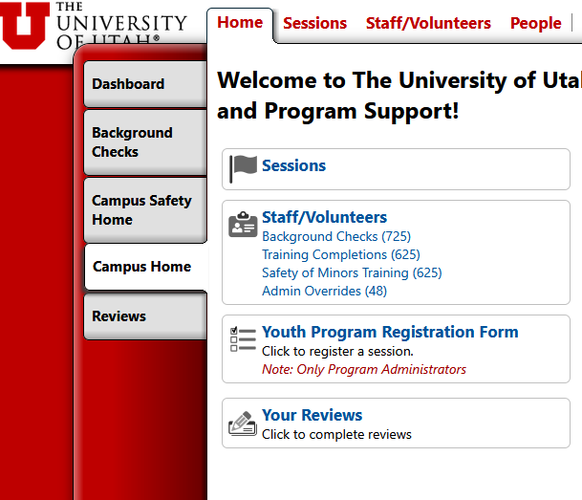

Click here to access the Session you want to edit

You will see a list of sessions that have been registered under your Program. Select the Session you want to edit.



Dashboard screen for editing the Session you have selected

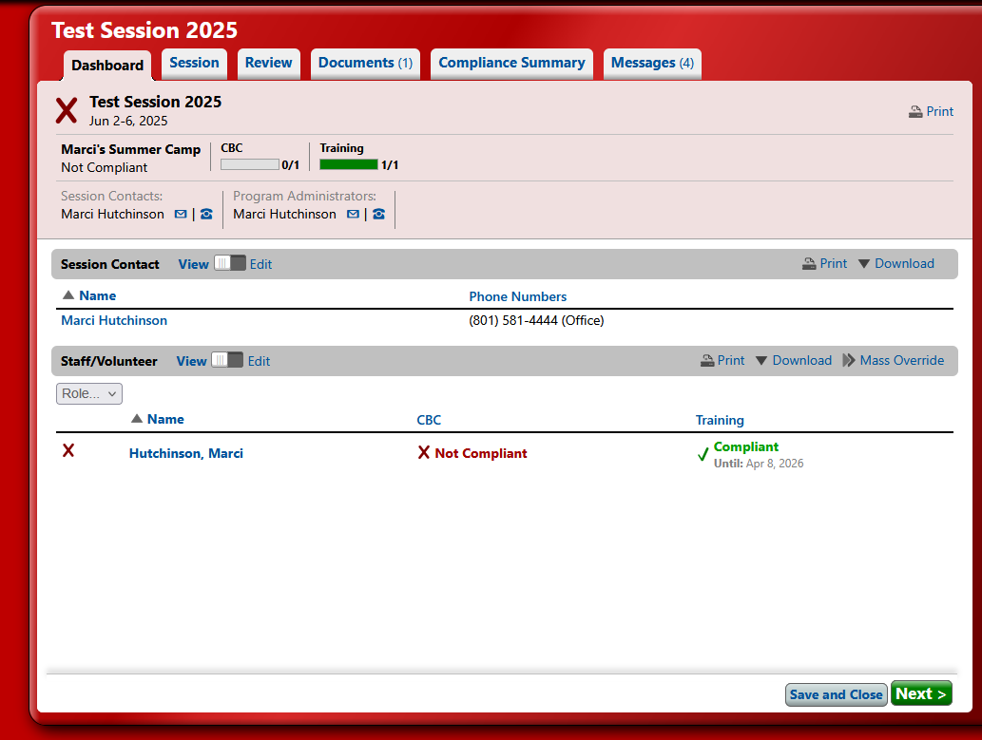

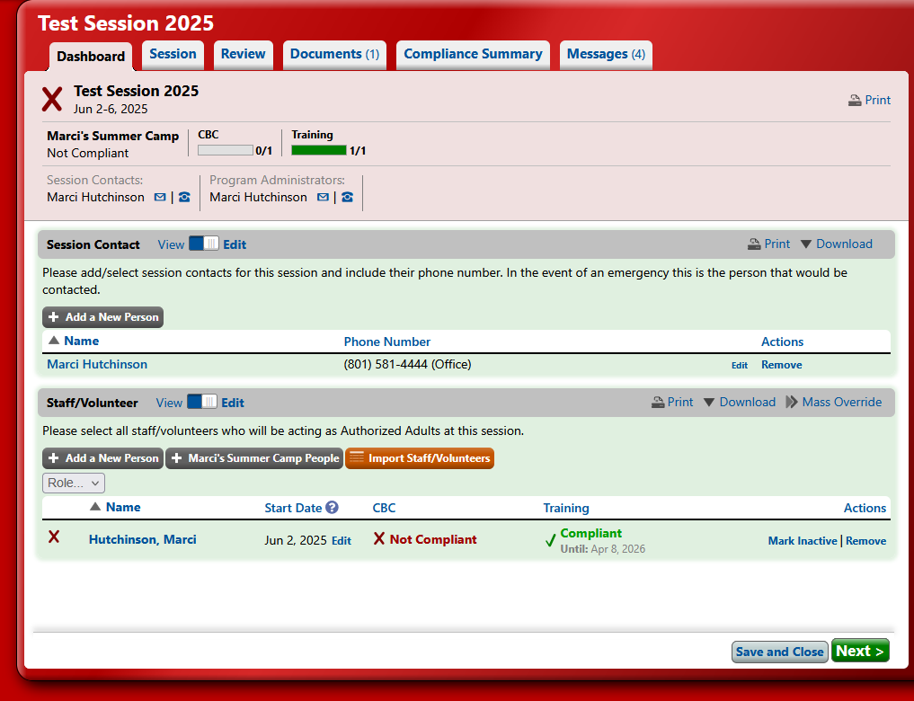

Toggle this button to “Edit” in order to add or edit Authorized Adult information

Toggle this button to “Edit” in order to add or edit a Session Contact

Adding Background Check Information

Step 1

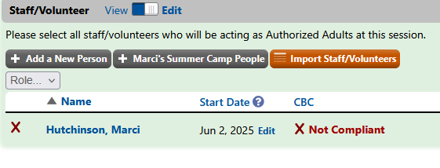

Click Here

Step 2

This will pop up when you click on “Not Compliant”:

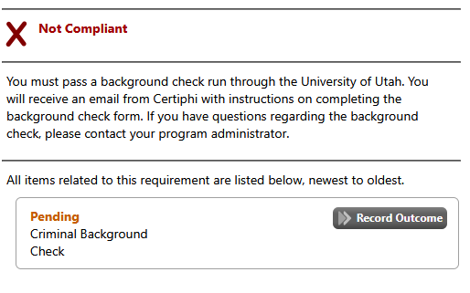

Click Here

Step 3

Input the date and select whether they were “Not Cleared” or “Cleared”

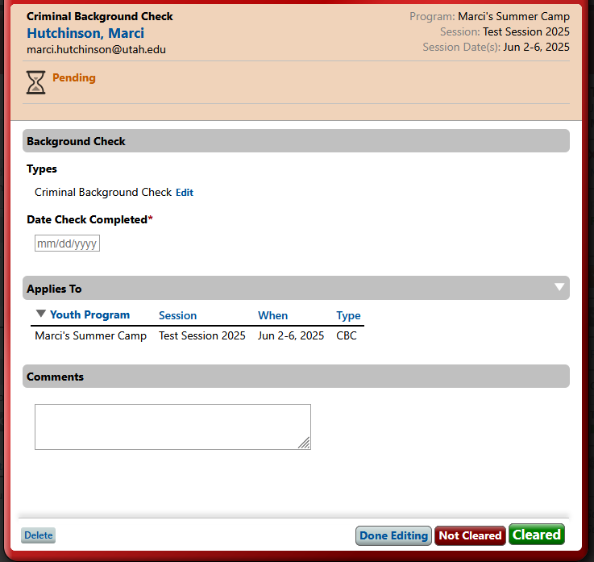

Adding Safety of Minors Training Information

Step 1

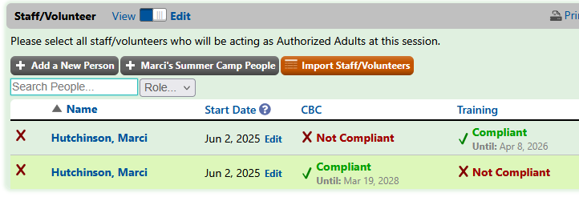

Click Here

Step 2

This will pop up when you click on “Not Compliant”:

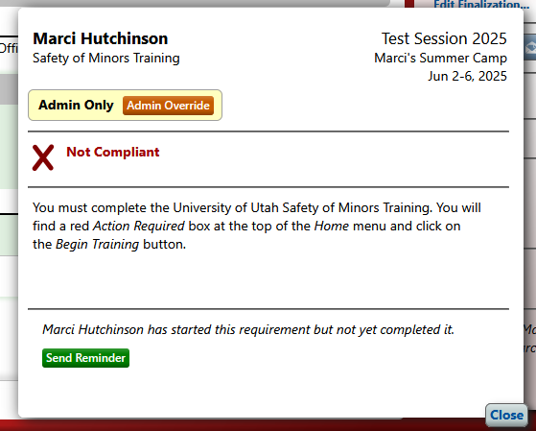

Click Here

Step 3

Leave the top selection, input the date they completed the training, click “Confirm Override”

